# Installing/Loading File

Note: If you are using a server version, you just need to upload the qvf file and load into Qlik Sense with the correct connection to the database. In addition, delete incremental data load tab/script and replace the SQL code in initial data load with the sql in the file called SQL – Server.txt.

1. You will need to register with Qlik.com to be able to log into the application. You can do so, at <https://qlikid.qlik.com/register>

* You can then download the desktop version here: <https://da3hntz84uekx.cloudfront.net/sense/production/Qlik_Sense_Desktop_setup.exe> (as of March 2020). **Install with the additional features (defaulted)**  
    
  *Note: The other option is here:* [*https://us-d.demo.qlik.com/download/*](https://us-d.demo.qlik.com/download/)*(You can filter to English, Qlik Sense Desktop, Latest release on the left side).*

1. After download, open Qlik Sense, log in (Note: You will need a license to do so).
   1. Note: You can save login information by checking the top right corner of the initial log-in page.
2. Close out of the welcome pop-up window.
   1. Note: you can uncheck the box to prevent this from appearing each time.
3. Now you can install the TCH Willow – Omnicell app. You have two options.
   1. Drag the attached file (.qvf) into the Qlik Sense software OR
   2. Save it the following location and it will appear in Qlik after restarting the app: C:\Users*[Your User ID]*Documents\Qlik\Sense\Apps

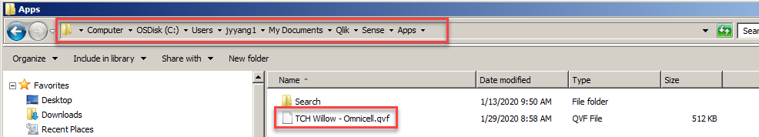

# Loading Initial Data

1. Select the TCH Willow – Omnicell application from your Qlik Sense Desktop Hub. Once opened, open the “Data load editor” by clicking on the left menu.

 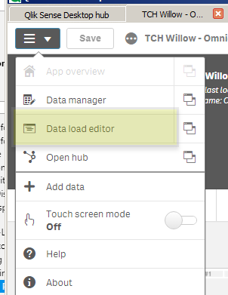

1. On the left side, click “Initial Data Load” and on the first line where it reads “exit script;” type “//” without quotes in front of the line.

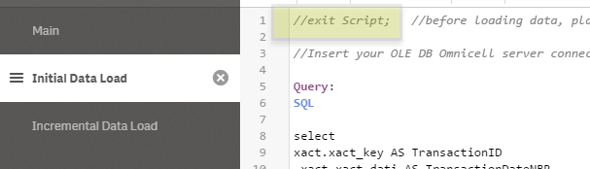

1. Creating a connection: Click on “Create a Connection” on the right pane and select “OLE DB”.

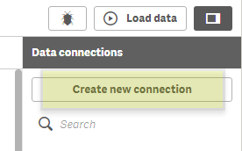

1. In the “Provider”, select “Microsoft OLE DB Provider for SQL Server”. Set to Specific user name and password.
2. In the “Data Source”, you will need to put your server information.
3. User name and password will be what is used to connect you to the server. You can click test connection to validate that it works. Afterwards, click “Create”.
   1. Note: Username may be OCGuest. Omnicell may need to set up the password for you.

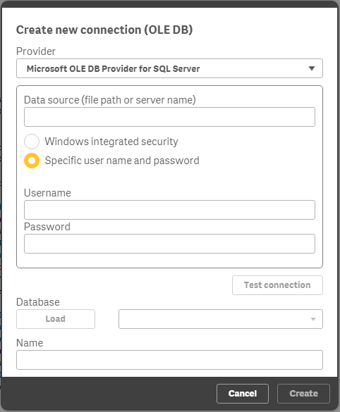

1. Create a folder connection to store the data into a QVD file for incremental loading: Click on “Create a Connection” on the right pane and select “Folder”.
   1. The default folder connection location is C:\Users*[Your User ID]*Documents
   2. Select a file path and name the folder connection

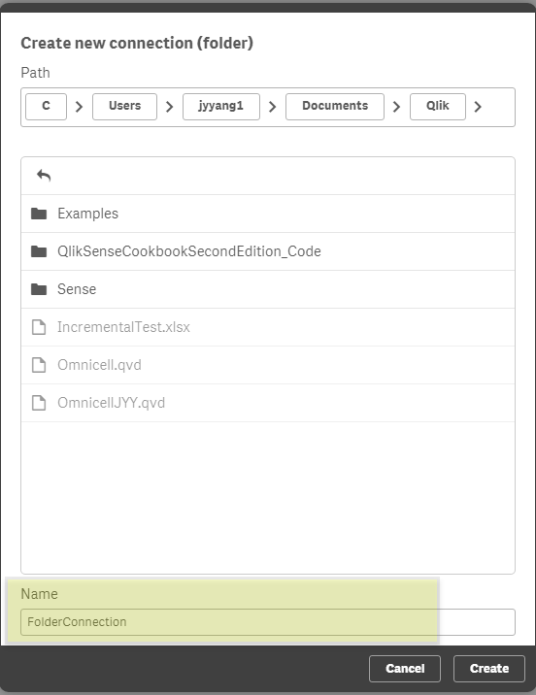

1. Insert the connection string to the Omnicell server by clicking the data connection on the right pane.

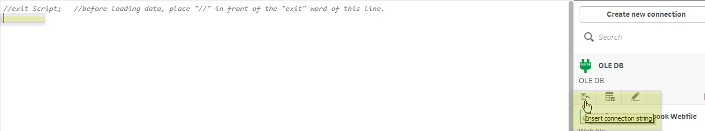

1. Insert the folder connection string just before the bottom “exit script” and name the QVD file.
   1. Change the TCH script to match the name of your folder connection and the desired file name.
   2. Syntax: ‘lib://FolderConnectionName/FileName.qvd'

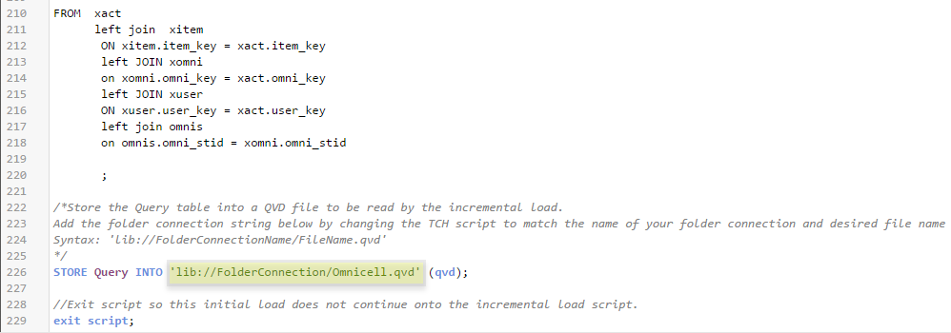

1. Afterwards, you can now click “Load Data” on top right corner.

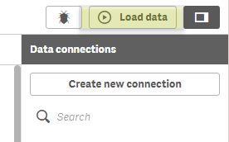

# Loading Incremental Load

1. Move the “Incremental Data Load” tab above the “Initial Data Load” tab on the left pane.

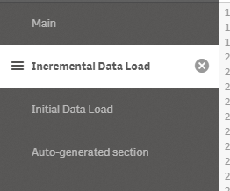

1. Insert the folder connection at the “load Transaction ID” script by changing the TCH script to match the name of your folder connection and the file name from the initial load.
   1. Syntax: [lib://FolderConnectionName/FileName.qvd]

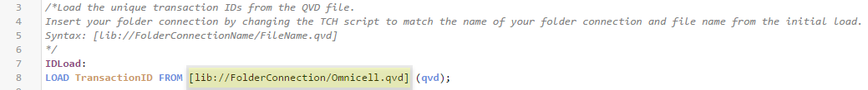

1. Insert connection string to the Omnicell server before the “UpdatedQuery” table by clicking the data connection on the right pane.
2. Insert the folder connection at the “load * from” script near the bottom of the query. Use the connection and file name as previously done.
   1. Syntax: [lib://FolderConnectionName/FileName.qvd]
3. Insert the folder connection string just before the bottom “exit script” with the name of the QVD file.
   1. Change the TCH script to match the name of your folder connection and use the previous file name
   2. Syntax: ‘lib://FolderConnectionName/FileName.qvd'

